**ONLINE SHOPPING SYSTEM**

**OBJECTIVE:**

The objective of the project is to make an application in android platform to purchase items in an existing shop. In order to build such an application complete web support need to be provided. A complete and efficient web application which can provide the online shopping experience is the basic objective of the project. The web application can be implemented in the form of an android application with web view.

**INTRODUCTION:**

This project is a web based shopping system for an existing shop .The project objective is to deliver the online shopping application into android platform .Online shopping is the process whereby consumers directly buy goods or services from a seller in real-time, without an intermediary service, over the Internet. It is a form of electronic commerce. This project is an attempt to provide the advantages of online shopping to customers of a real shop .It helps buying the products in the shop anywhere through internet by using an android device. Thus the customer will get the service of online shopping and home delivery from his favorite shop.

The central concept of the application is to allow the customer to shop virtually using the Internet and allow customers to buy the items and articles of their desire from the store. The information pertaining to the products are stores on an RDBMS at the server side (store).

**SOFTWARE REQUIREMENTS FOR PRESENT PROJECT:**

OPERATING SYSTEM : Windows 7/ XP/8

FRONT END : Html ,java script.

SERVER SIDE SCRIPT : jsp

DATABASE : Mysql

**SAMPLE CODE:**

LOGIN PAGE:

<%@include file="template/top.jsp" %>

<%@include file="template/menu_public.jsp" %>

<%@include file="template/body_start.jsp" %>

<form id="form" action="loginbaseselect.jsp">

<table>

<tr>

<td><input type="text" name="uname" id="uname" placeholder="username" required="" />

</td>

</tr>

<tr>

<td><input type="password" name="upass" id="upass" placeholder="password" required="" /></td>

</tr>

<tr>

<td><button class="button" type="submit" id="search-submit">Login</button> </td>

<td>

<div id="result"></div>

</td>

</tr>

</table>

</form>

<script type="text/javascript">

<%

if (request.getParameter("login") != null &&request.getParameter("login").contentEquals("failed")) {%>

alert("Login Failed !!!");

<% }%>

<%if (request.getParameter("login") != null &&request.getParameter("login").contentEquals("dissabled")) {%>

alert("User Blocked !!!");

<% }%>

<%if (request.getParameter("login") != null &&request.getParameter("login").contentEquals("unknown")) {%>

alert("Unknown user !!!");

<%

%>

</script>%@include file="template/body_end.jsp" %

REGISTRATION:

<%@page import="DataBase.DB"%>

<%@page import="java.sql.ResultSet"%>

<%@include file="template/top.jsp" %>

<%@include file="template/menu_public.jsp" %>

<%@include file="template/body_start.jsp" %>

<h2 class="title"><a href="#">Register </a></h2>

<div class="entry">

<form action="dbregister.jsp" onsubmit="return check()">

<table>

<tr>

<td>User Name</td>

<td><input type="text" required="" name="uname" id="uname" /></td>

</tr>

<tr>

<td>Password</td>

<td><input type="password" required="" name="upass" id="upass" /></td>

</tr>

<tr>

<td>Login Name</td>

<td><input type="text" required="" name="lname" id="lname" /></td>

</tr>

<tr>

<td>Email</td>

<td><input type="email" name="emailid" id="emailid" /></td>

</tr>

<tr>

<td>Mobile No.</td>

<td><input type="text" name="mobno" id="mobno" /></td>

</tr>

<tr>

<td></td>

<td><button class="button" type="submit">Register</button></td>

</tr>

</table>

</form>

</div>

<script type="text/javascript">

<%if (request.getParameter("reg") != null &&request.getParameter("reg").contentEquals("failed")) {%>

alert("Registration Failed !!!");

<% }%>

<%

if (request.getParameter("reg") != null &&request.getParameter("reg").contentEquals("success")) {%>

alert("Registration Completed")

<% }%>

</script>%@include file="template/body_end.jsp" %

DB REGISTRATION:

<%@page import="config.Config"%>

<%@page import="java.io.File"%>

<%@page import="java.sql.ResultSet"%>

<%@page import="DataBase.DB"%>

<%if (DB.executeUpdate("insert into login values("+ "null" + ",'"+ request.getParameter("uname") + "',SHA1('"+ request.getParameter("upass") + "'),'"+ "user" + "','"+ "false" + "')")) {ResultSet r = DB.executeQuery("select max(uid) from login");r.next();String uid = r.getString(1);if (DB.executeUpdate("insert into userdetails values("+ uid + ",'"+ request.getParameter("lname") + "','"+ request.getParameter("emailid") + "','"+ request.getParameter("mobno") + "')")) { // this code generates the qr code inside the QR_Code folderin the c driveresponse.sendRedirect("index.jsp?reg=success");}} else {response.sendRedirect("register.jsp?reg=failed");}

%>

<%@page import="DataBase.DB"%>

<%@page import="java.sql.ResultSet"%>

<%String uname = request.getParameter("uname");String upass = request.getParameter("upass");

ResultSet r = DB.executeQuery("select * from login whereuname='" + uname + "' and upass=SHA1('" + upass + "')");

if (r != null && r.next()) {

if (r.getString("enabled") != null &&r.getString("enabled").contentEquals("true")) {

session.setAttribute("uname", uname);

session.setAttribute("uid", r.getString("uid"));session.setAttribute("utype",r.getString("utype"));

if (r.getString("utype").contentEquals("admin")) {

response.sendRedirect("adminindex.jsp");

}

else if (r.getString("utype").contentEquals("mod"))

{

response.sendRedirect("modindex.jsp");

}

else if (r.getString("utype").contentEquals("user"))

{

response.sendRedirect("userindex.jsp");

}

else {

session.setAttribute("uname", null);session.setAttribute("uid", null);

session.setAttribute("utype",null);response.sendRedirect("login.jsp?login=unknown");

}}

else {

response.sendRedirect("login.jsp?login=dissabled");

}} else {

response.sendRedirect("login.jsp?login=failed");

}%>

DATABASE CONNECTION:

package DataBase;import java.sql.*;

public class DB {

static Connection con = null;

static Statement stmt = null;static ResultSet rs = null;

public static Connection getConnection()

{try

{Class.forName("com.mysql.jdbc.Driver");

con =DriverManager.getConnection("jdbc:mysql://localhost:3306/online_shopping", "root", "root");}

catch (Exception e) {

System.out.println("Exception" + e);}return con;

}

public static boolean executeUpdate(String query)

{

boolean f = false;try

{con = getConnection();

stmt = con.createStatement();

int b = stmt.executeUpdate(query);

if (b > 0) {f = true;}

else { f = false;}}

catch (Exception e)

{System.out.println("Exception" + e);

}return f;

}

public static ResultSet executeQuery(String sql) {try {con = getConnection();

stmt = con.createStatement();

rs = stmt.executeQuery(sql);return rs;}

catch (Exception e) {System.out.println("Exception" + e);return null; }}

public static void close() {try {con.close();stmt.close();

rs.close();}

catch (Exception e) {System.out.println("Exception" + e);

}

}}

**SCREEN SHOTS:**

LOGIN:

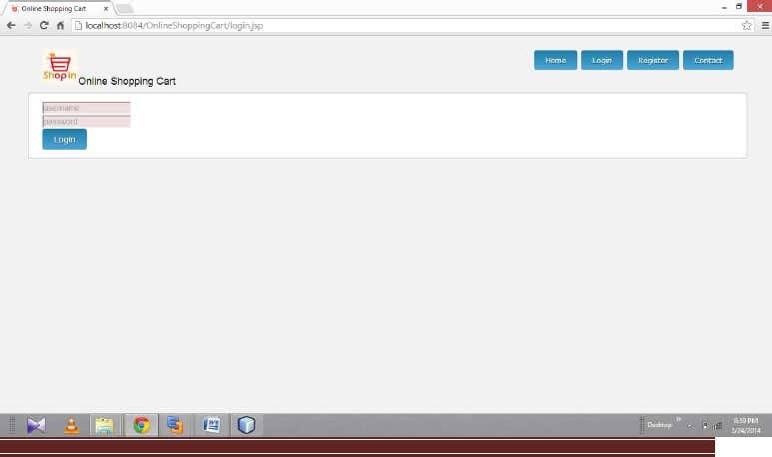

REGISTRATION:

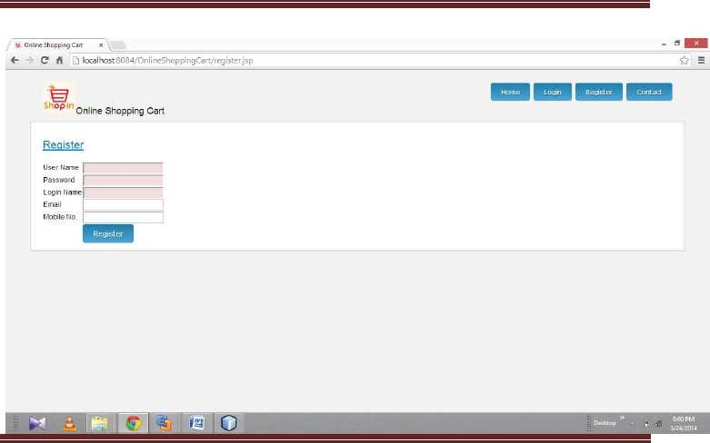

USER HOME:

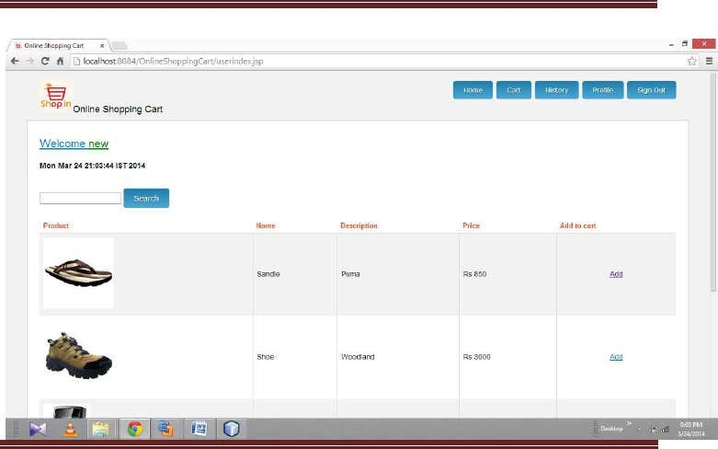

USER CART:

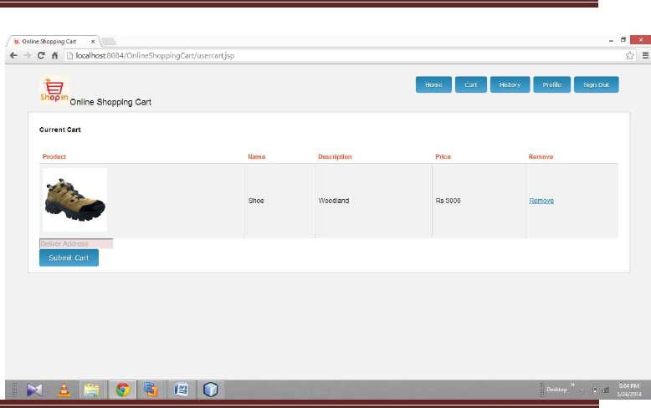

**CONCLUSION:**

The project entitled Online shopping system

was completed successfully. The system has been developed with much care and free of errors and at the same time it is efficient and less time consuming. The purpose of this project was to develop a web application and an android application for purchasing items from a shop. This project helped us in gaining valuable information and practical knowledge on several topics like designing web pages using html & css , usage of responsive templates, designing of android applications, and management of database using mysql . The entire system is secured .Also the project helped us understanding about the development phases of a project and software development life cycle. We learned how to test different features of a project .This project has given us great satisfaction in having designed an application which can be implemented to any nearby shops or branded shops selling various kinds of products by simple modifications .There is a scope for further development in our project to a great extend .A number of features can be added to this system in future like providing moderator more control over products so that each moderator can maintain their own products. Another feature we wished to implement was providing classes for customers so that different offers can be given to each class. System may keep track of history of purchases of each customer and provide suggestions based on their history. These features could have implemented unless the time did not limited us.